Exploratory Data Analysis on the South African imports from Lesotho Dataset

Introduction
The South African imports from Lesotho data set was originally written by the South African Revenue Services (SARS), it contains data on products that were imported from Lesotho, this data includes the months, tariffs, quantities, customs value, district offices and brief descriptions of the products imported. Lesotho is a landlocked country in the south eastern part of South Africa, most imports are done through vehicle transportation from various district offices in Lesotho.
DATA CLEANING
The data set initially had 21 columns, some of the columns contained abbreviations of the following columns which was basically duplication of information, these columns were dropped, additionally there were columns that contained the same values throughout for example the world region column only had ‘Africa’ since the import was in Africa, similarly the type of trade column only had ‘import’ since the data is on importing goods, such columns were also dropped. Duplicated rows were checked using the duplicated () function, there were no duplicated rows in the dataset.

MISSING DATA
Missing data was checked using the isnull () and sum () functions, missing data was found in only two columns. The first was the statistical unit function which had 10 missing values, the second was the tariff and description column which had 5 missing values. Both these columns are categorical data hence I used the mode of each column to fill in the missing values, I used the fillna () function to achieve this.

DATA STORIES AND VISUALISATIONS

Analysing the district offices in Lesotho where the products were imported

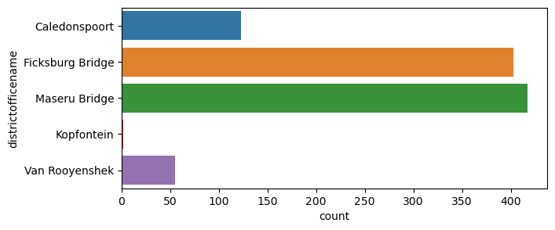
Most products imported to South Africa were imported from the Maseru Bridge and the Ficksburg Bridge.

Analysing the months in which most import occurred

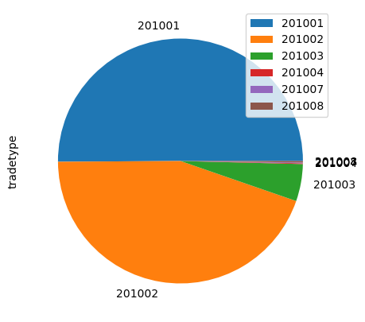

Imports to South Africa were mostly done in January (201001) and February (201002), this may have been because there was a high demand of certain goods during this period.

Analysing the section and description column which essentially highlights the product being imported
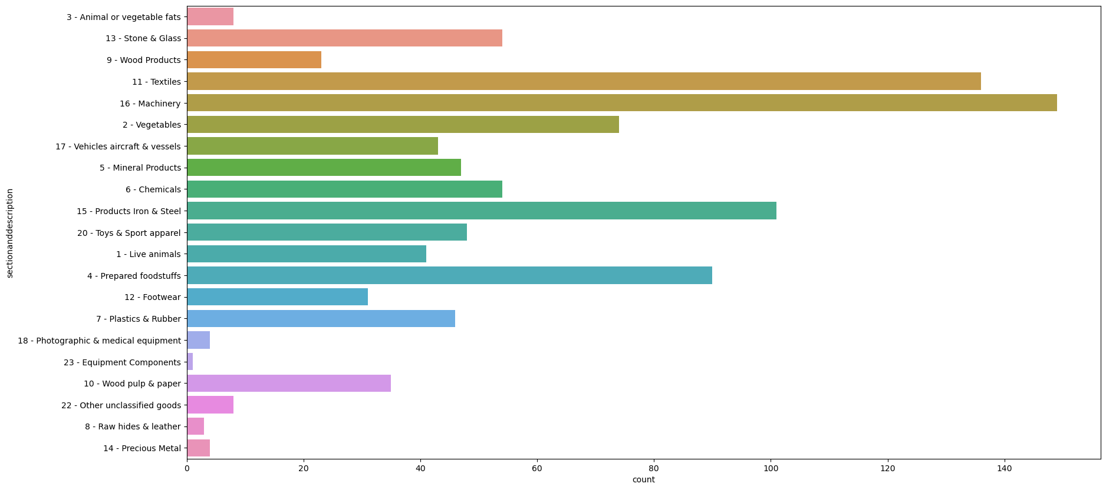

The most frequent products to be imported from Lesotho to South Africa are machinery, textiles and iron and steel products. This may mean that South Africa does not have enough companies that produce machinery, textiles and iron and steel products hence they purchase these from Lesotho or there is a high demand for these products and imports are needed to meet these demands, it may also be that products from Lesotho are cheaper than those from local manufacturers. South Africa was hosting the world cup in 2010 perhaps the machinery was needed for construction, and textiles for buildings and renovation for tourism purposes.

Analysing the description of products
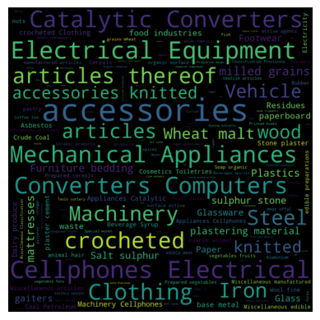

The word cloud above shows the description of the items that are imported to South Africa, the items that are mostly imported are mechanical appliances, converters, computers, machinery, cell phones, clothing, iron, electrical equipment, catalytic converters, wood, etc. products that are less frequently imported are paper, glassware, sulphur, stone, asbestos, crude, coal, waste, etc.

Analysing the correlation between customs value, tariffs, and quantity
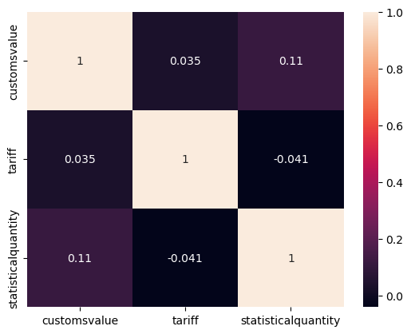

The correlation between customs value and statistical quantity is not very high however is does show that the quantity does affect the customs value. The correlation between customs value and tariff is low which shows that the tariff charged on goods is not directly related to the custom value of the goods, lastly the tariff and statistical quantity have a negative correlation which shows that they do not depend on each other in any significant way.

Analysing products with the highest customs value
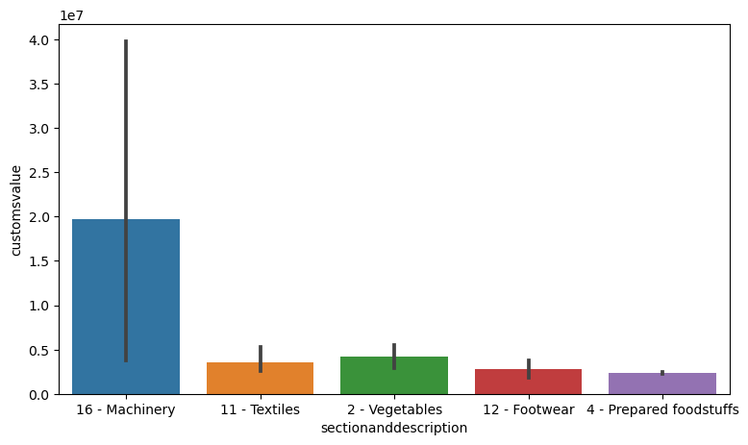
Machinery has the highest customs value in the data, this makes sense as most machinery is generally expensive, vegetables have the second highest customs value, generally vegetables do not cost more than textiles and footwear, perhaps in this data they are expensive because they might have been bought in bulk.

Analysing products that were bought in high quantities
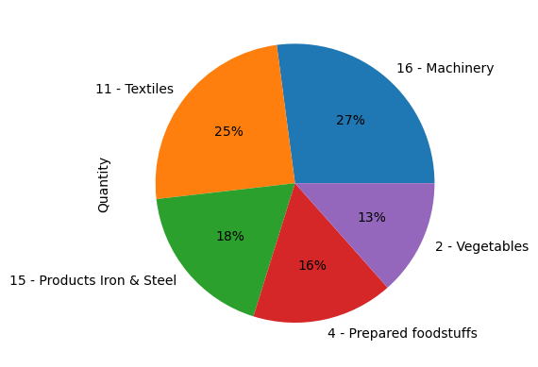

Machinery has the highest quantity which also explains why is has high customs value since we observed in the heat map above that quantity does correlate (0.11) with customs value, it makes sense that products with high quantity can also have high customs value. the second product with high quantity is textiles followed by products of iron and steel. Products of iron and steel have high quantities but low customs value, this can also be expected as the correlation between customs value and quantity is only 0.11, perhaps these products of iron and steel are used goods. Vegetables has the lowest quantity out of the top 5, but has customs value that is higher than textiles and prepared foods, this may be because of some value in the vegetables like the soil type and climate in Lesotho, this could also be due to a high demand of vegetables in South Africa.

Analysing the top 5 products with the highest tariffs

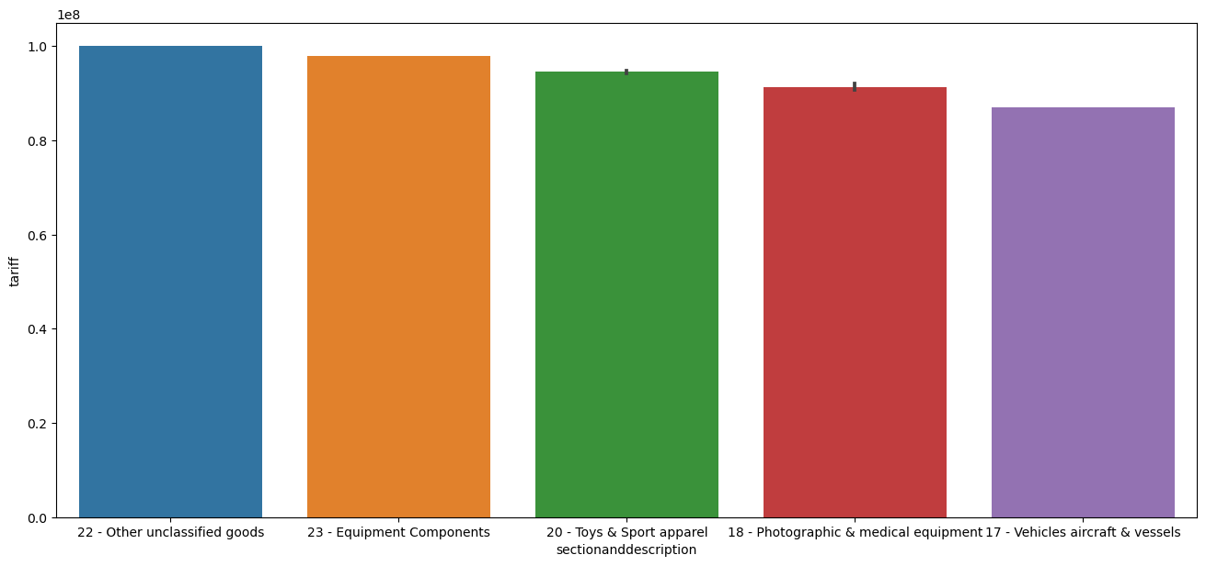
The products with the highest tariffs are unclassified goods, followed by equipment, toys and sport apparel and photographic and medical equipment, we observe that the products with the highest tariff are not the same as the ones with the highest customs value, this is expected as the correlation between tariff and customs value is only 0.035.

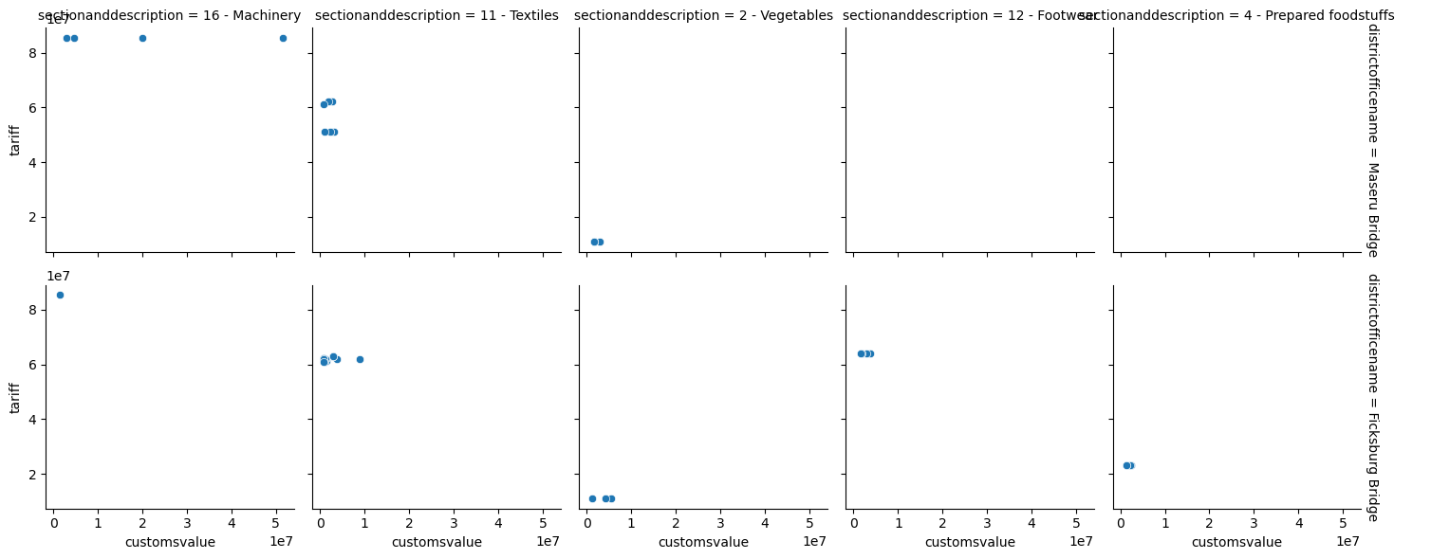
Analysing the top 5 products with high customs value and their tariff and district they were imported from

From the scatter plot we observe that most products come mainly from Maseru Bridge and Ficksburg Bridge, Machinery mostly comes from Maseru Bridge as well as some textiles and vegetables, most textiles, footwear and prepared foods come from Ficksburg Bridge, from the scatter plot we also observe that vegetables have low tariffs as compared to the other products. From the scatter plot we observe that most products come mainly from Maseru Bridge and Ficksburg Bridge, Machinery mostly comes from Maseru Bridge as well as some textiles and vegetables, most textiles, footwear and prepared foods come from Ficksburg Bridge, from the scatter plot we also observe that vegetables have low tariffs as compared to the other products. Most machinery and textiles may be produced near Maseru bridge, there could be an industrial area near Maseru bridge, most prepared food and vegetables are imported from Fiscksburg bridge this could mean that there is an agricultural area near Ficksburg bridge.

Analysing vegetables and prepared foods to see what time of the year they were imported
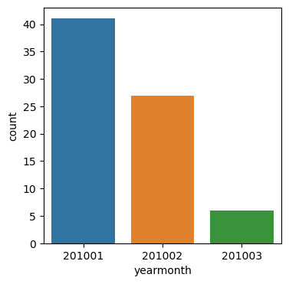
Vegetables were imported mostly in summer, this could mean certain crops that grow well in Lesotho during these months because of favourable conditions that Lesotho might have such as soil type and climatic conditions or this could mean there was a high demand for vegetables in South Africa and they needed more imports to meet their demand, most vegetables were imported in January.
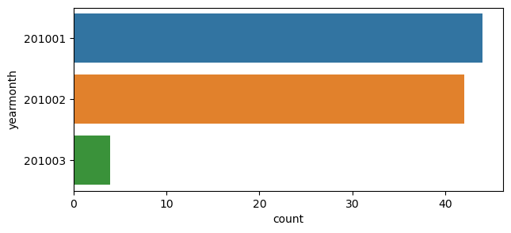

Most prepared foods were imported in January and February, this may be because there was a high demand for prepared foods for South Africans located around the Ficksburg bridge, another possibility is that perhaps there was a lot of travel around that area or a lot of work such as construction work since 2010 was the year of the world cup in South Africa, there was a lot of work and travelling during this time.

Conclusion

South Africa imports many different products from Lesotho, the most common products that are imported are machinery, textiles, vegetables footwear and prepared foods, this data is based on 2010 which was the year South Africa was hosting the world cup, there was a lot of effort made to better the countries’ infrastructure and tourism facilities, this many have been the main reason for the high imports of machinery and textiles, in addition most imports were done in January and February which may have been because preparations for the world cup were still undergoing. Lesotho also provides a lot of vegetables to South Africa this may be due to the rise in population numbers hence the rise in demands for food rise and imports are one of the ways to meet demands. The data shows that there is a low correlation between tariffs and customs value hence products are charged tariffs and customs value based on the kind of products they are that’s why you find some products with high customs value and low tariffs or vice versa.

THIS REPORT WAS WRITTEN BY: Naledi Msiya

